|  |  |
| --- | --- |
| **Exp No: 2**  **Date: 19.2.25** | **REGISTRATION FORM** |

**AIM:**

To write a JavaScript to validate the following fields of a registration page   
a) First Name ( Name should contain alphabets and the length should not be less than 6 characters

b)Password (Password should not be less than 6 characters length)

c)Email id ( should not contain any invlaid and must follow the standard pattern [name@domain.com](mailto:name@domain.com))

d)Mobile Number(phone number should contain 10 digits only )

e)Last Name and Address ( should not be Empty)

**PROGRAM:**

<html>

<head>

<title>Registration Form</title>

<script>

function validateForm() {

let name = document.forms["regForm"]["name"].value;

let password = document.forms["regForm"]["password"].value;

let email = document.forms["regForm"]["email"].value;

let mobile = document.forms["regForm"]["mobile"].value;

if (!/^[A-Za-z]+$/.test(name)) {

alert("Name must be alphabetic only");

return false;

}

if (password.length < 6) {

alert("Password must be at least 6 characters");

return false;

}

if (!email.includes("@")) {

alert("Invalid email format");

return false;

}

if (!/^\d{10}$/.test(mobile)) {

alert("Mobile number must be 10 digits");

return false;

}

alert("Form successfully submitted!");

return true; // allows form to submit (to same page or backend if added)

}

</script>

</head>

<body>

<center>

<h2>Registration Form</h2>

<form name="regForm" onsubmit="return validateForm()" action="#">

<label for="name">Name:</label><br>

<input type="text" name="name" id="name" required><br><br>

<label for="password">Password:</label><br>

<input type="password" name="password" id="password" required><br><br>

<label for="email">Email:</label><br>

<input type="text" name="email" id="email" required><br><br>

<label for="mobile">Mobile:</label><br>

<input type="text" name="mobile" id="mobile" required><br><br>

<input type="submit" value="Register">

</form>

</center>

</body>

</html>

**OUTPUT:**

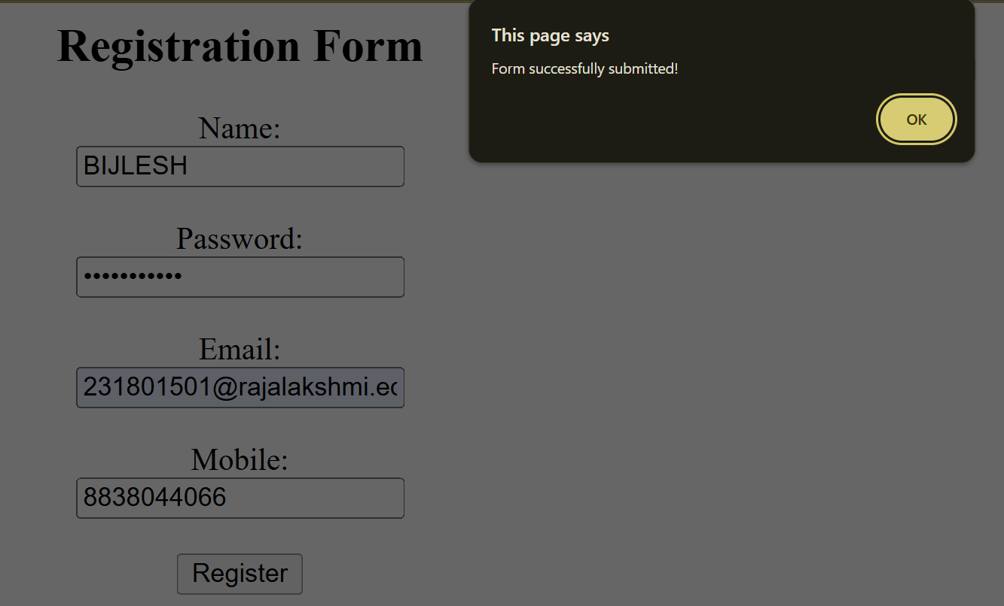

**RESULT :**Thus the experiment to create a web page that embeds a map with hotspots, frames, and links using embedded, external, and inline CSS has been successfully implemented and verified .